

**Program :**B.tech(CSE)

**Specialization :**AIML

**Course Title :**AI Assisted Coding

**Course Code :**24CS002PC215

**Semester :**3rd semester

**Academic Session :**2025-2026

**Name of Student :**BachanagariDeekshitha

**Enrollment No. :**2403A52032

**Batch No. :**02

**Date :**9/09/2025

#LAB ASSIGNMENT

Task Description -1:

Use an AI tool (e.g., Copilot, Gemini, Cursor) to generate a login system. Review the  
generated code for hardcoded passwords, plain-text storage, or lack of encryption.

#PROMPT:

Create a secure login system in Python with user registration, login authentication, and password handling, using best practices like password hashing and input validation, and review the code for hardcoded passwords, plain-text storage, and missing encryption.

* QUESTION:

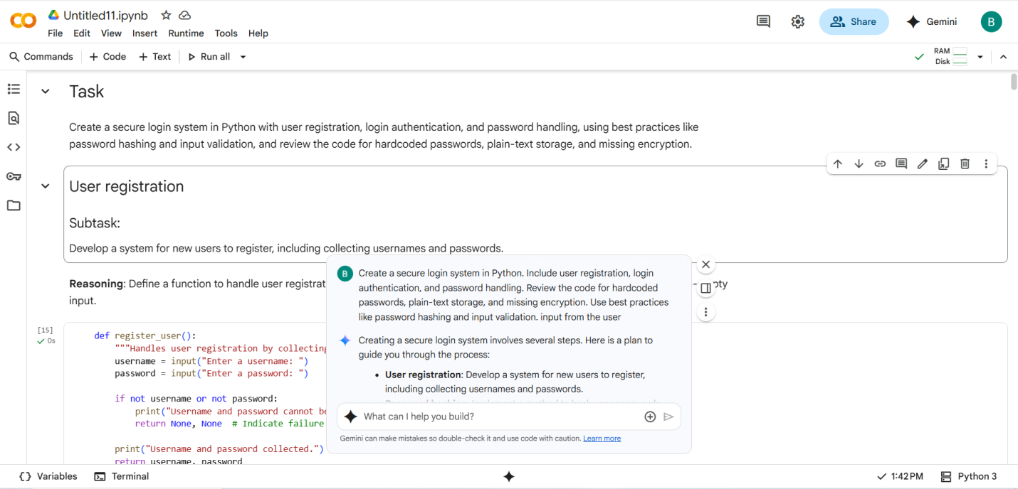

* CODE with OUTPUT:

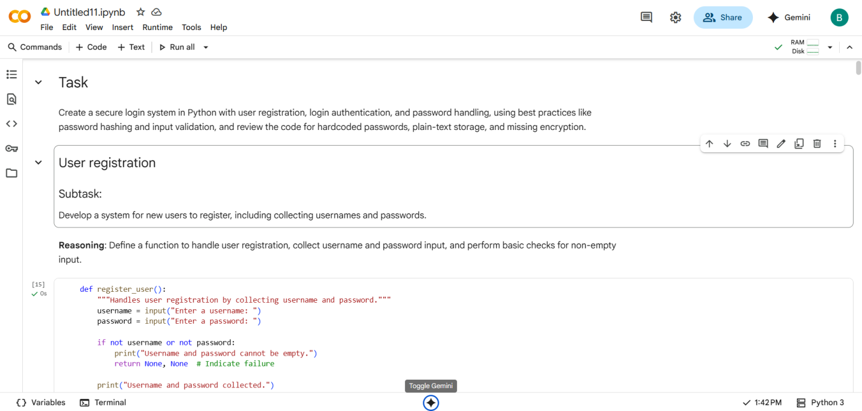

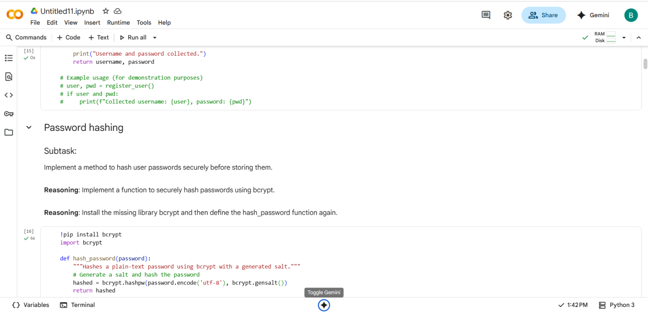

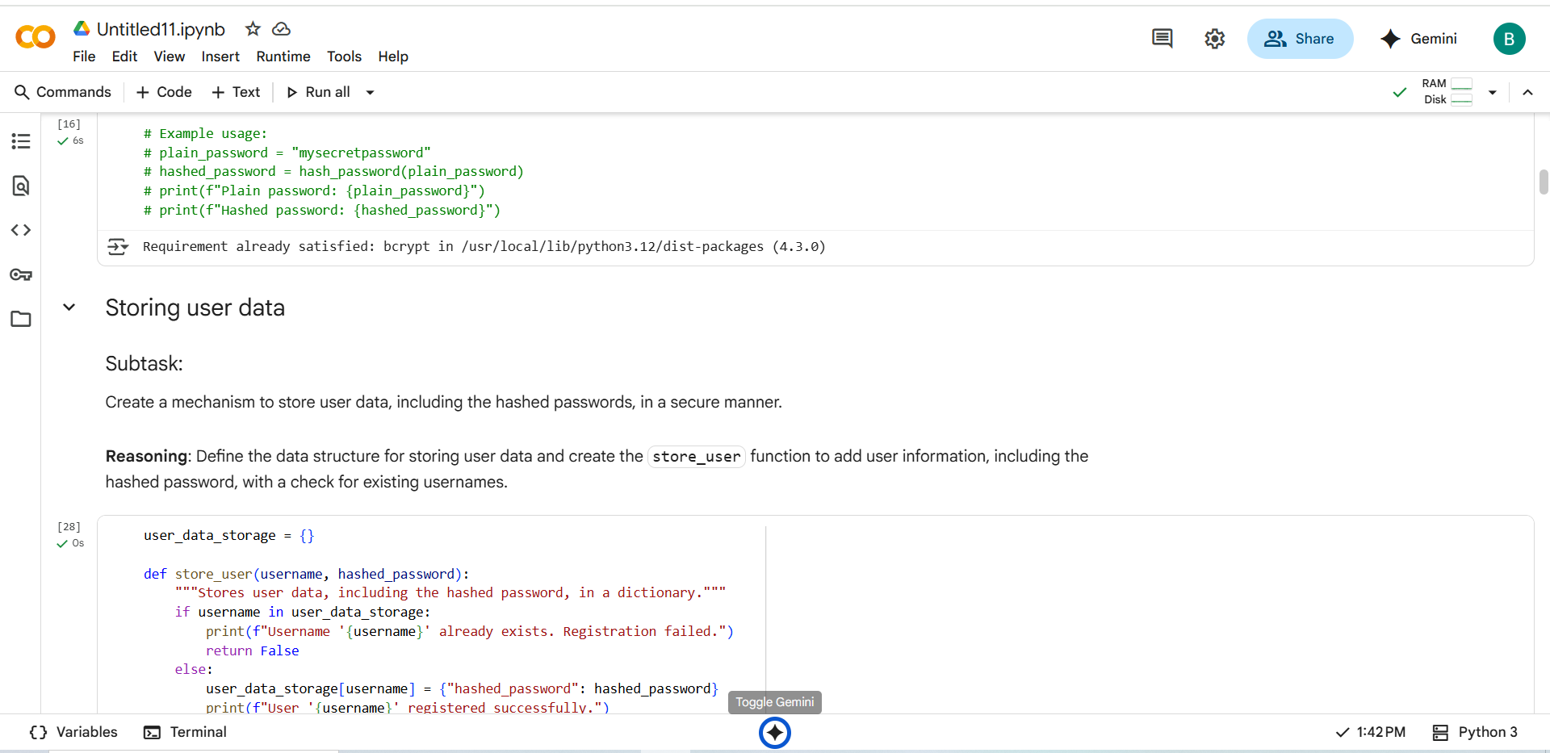

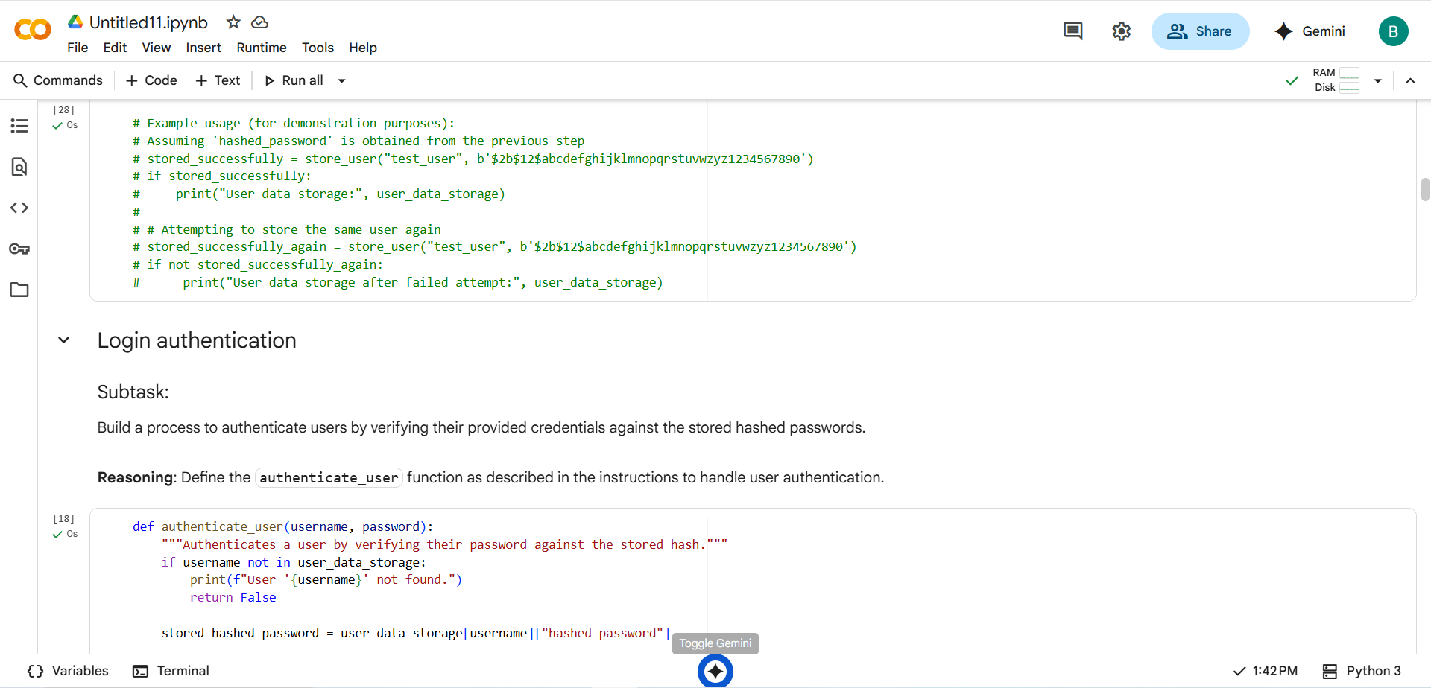

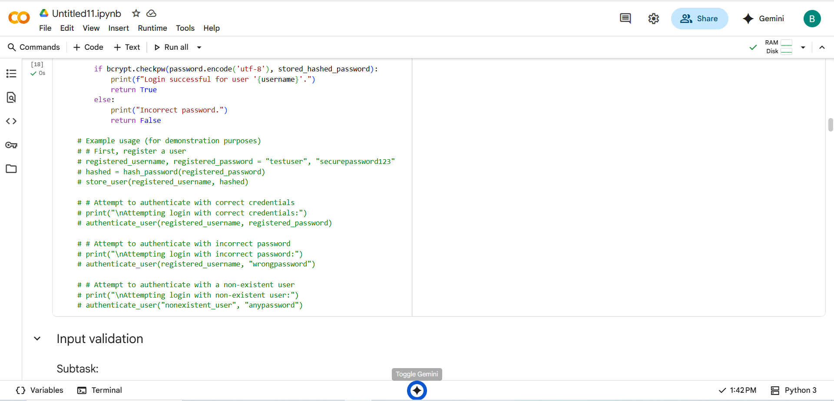

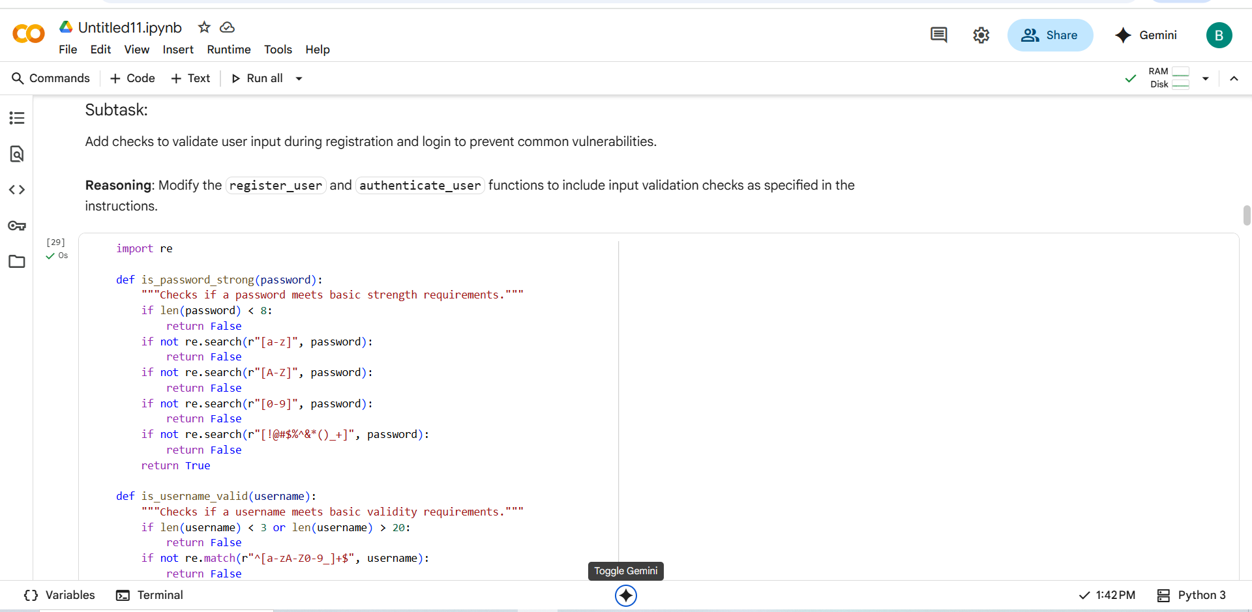

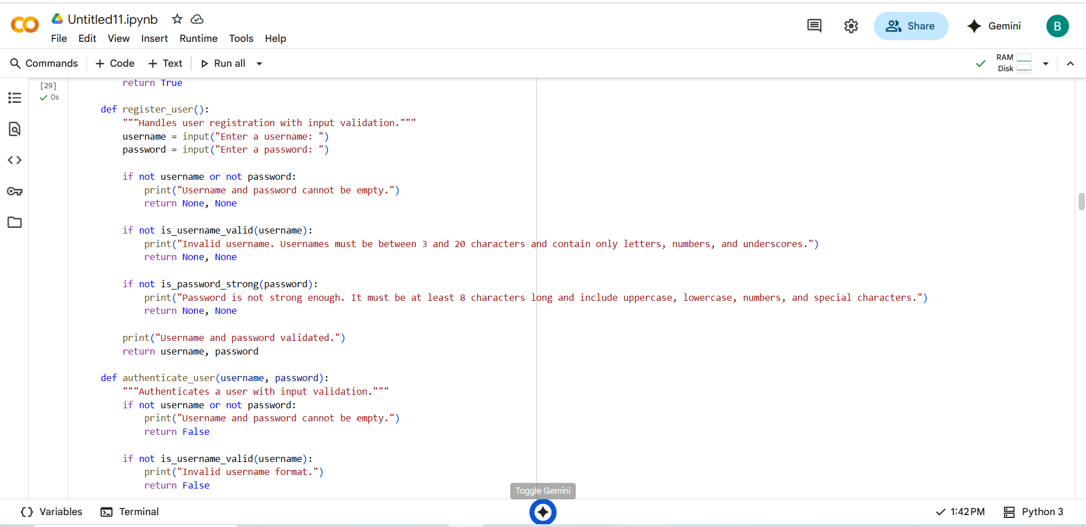

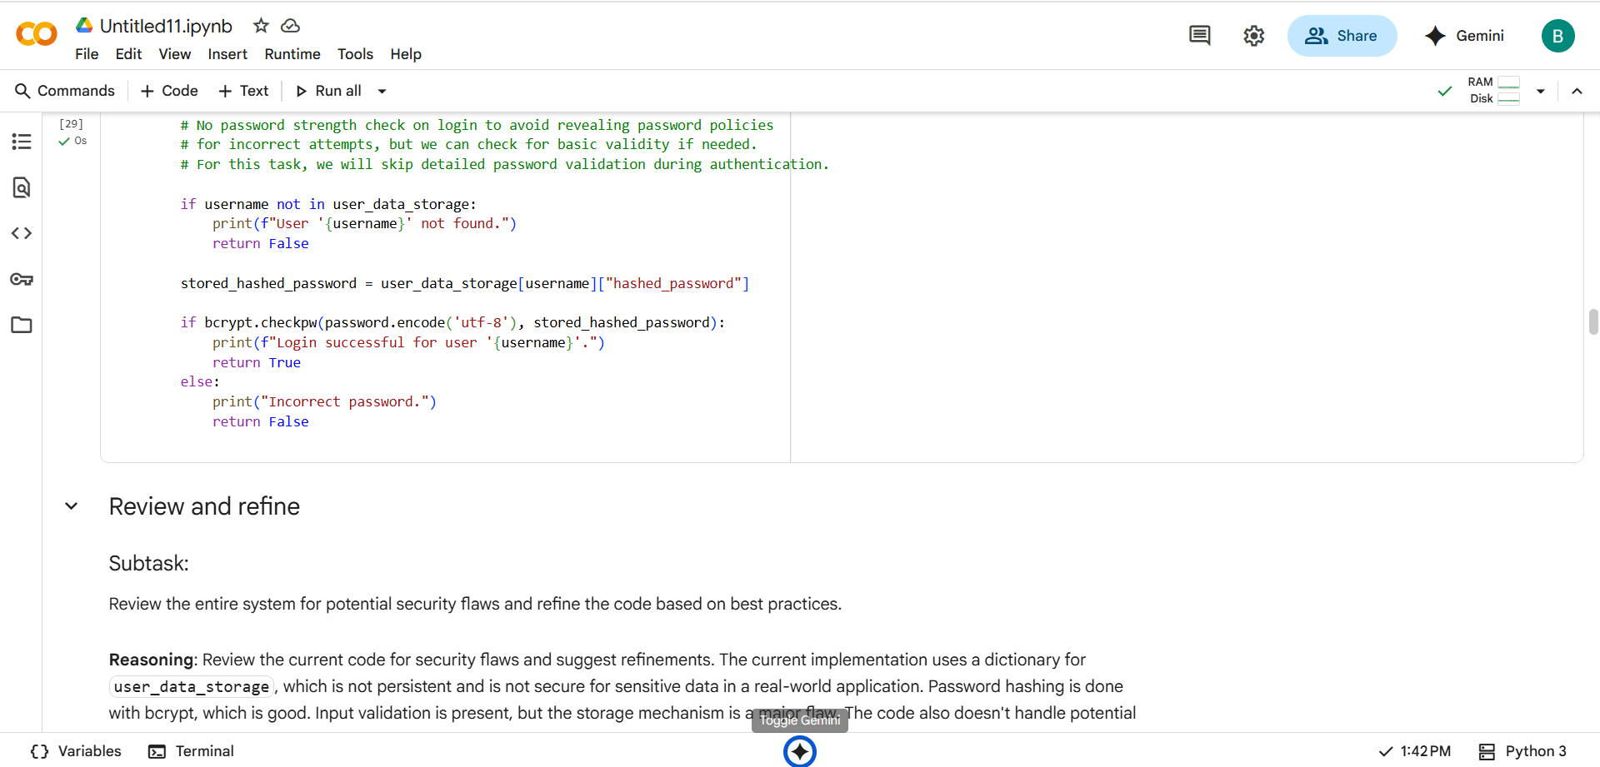

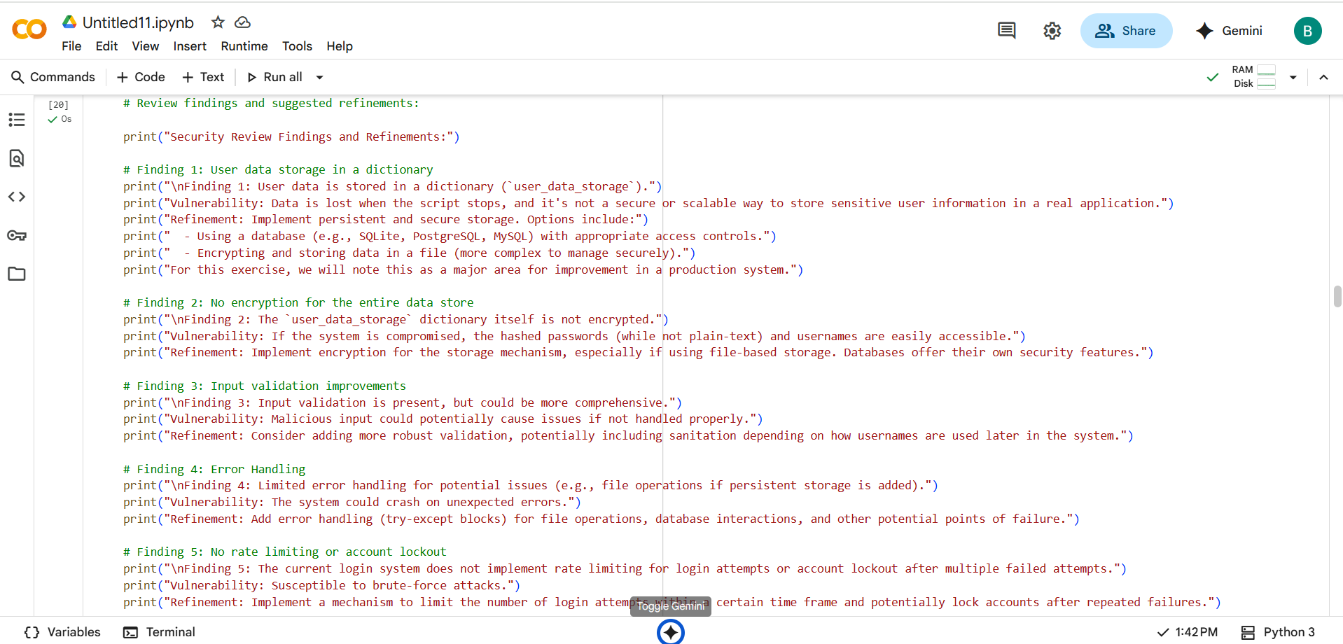

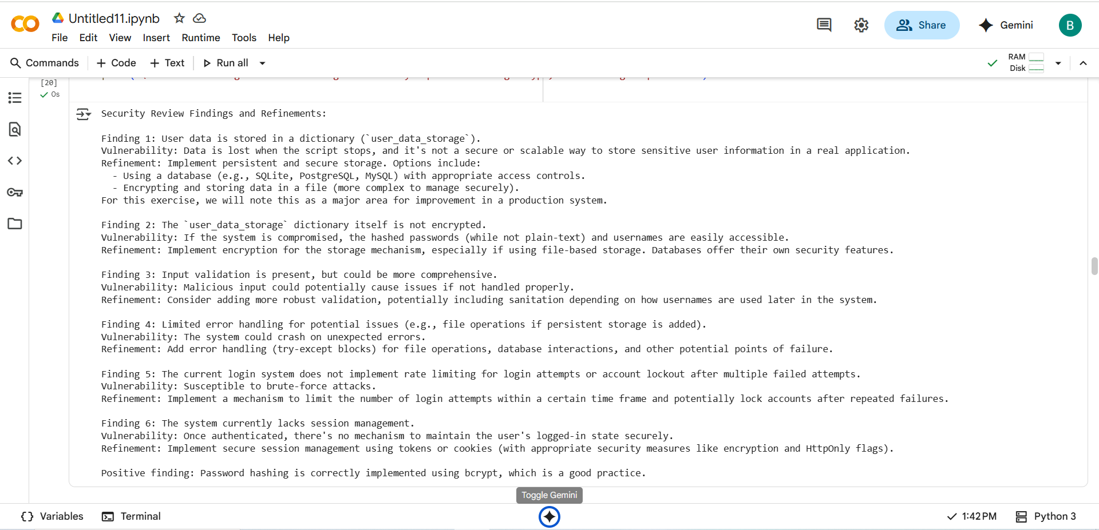

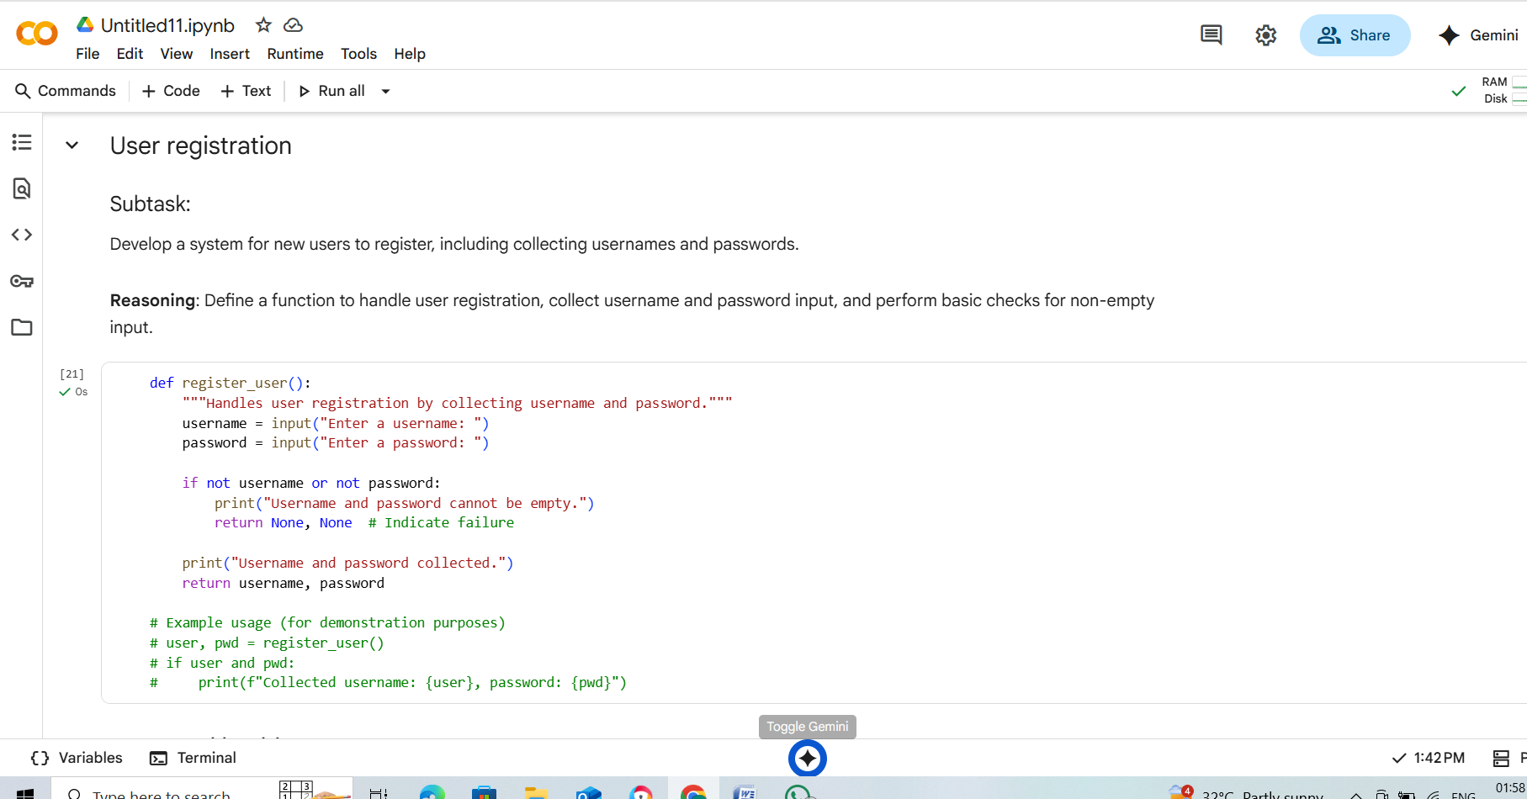

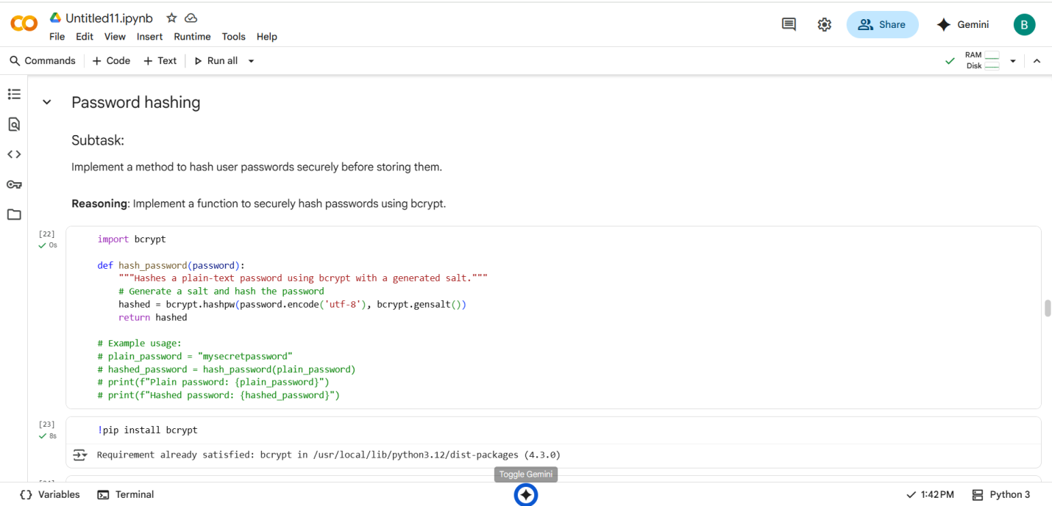

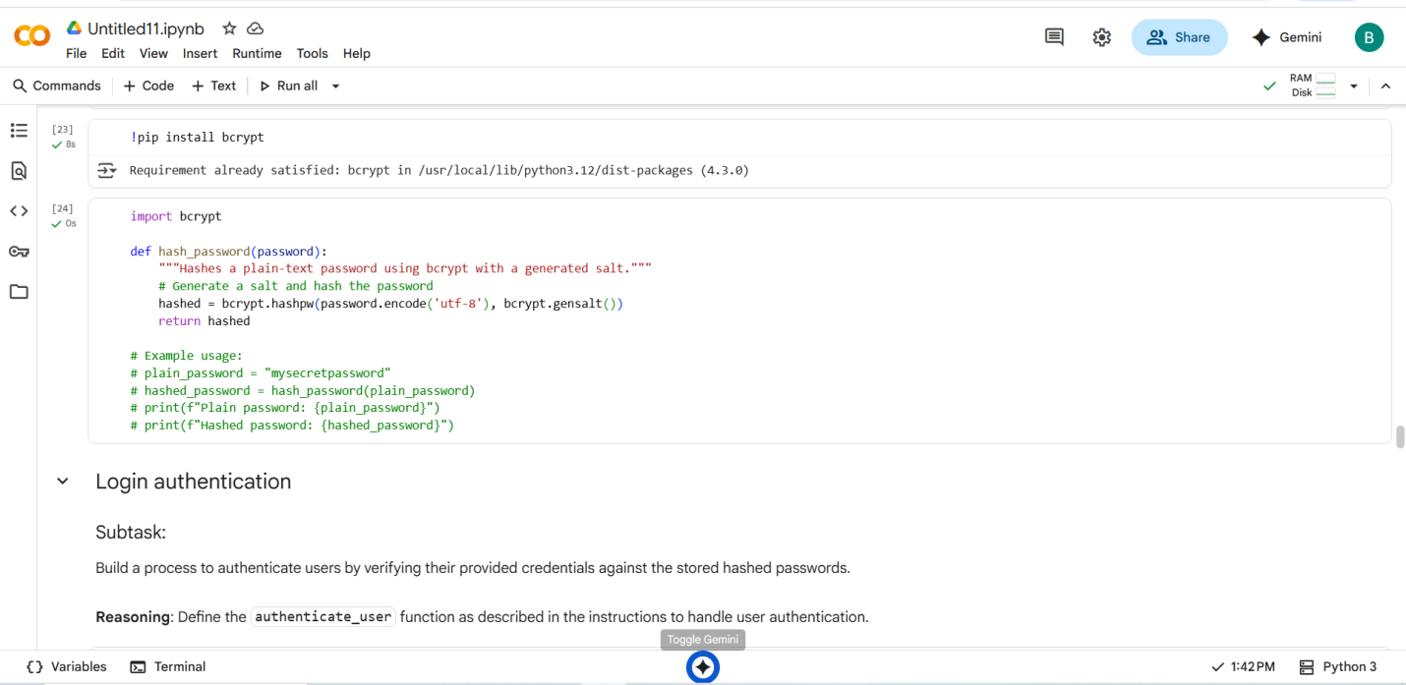

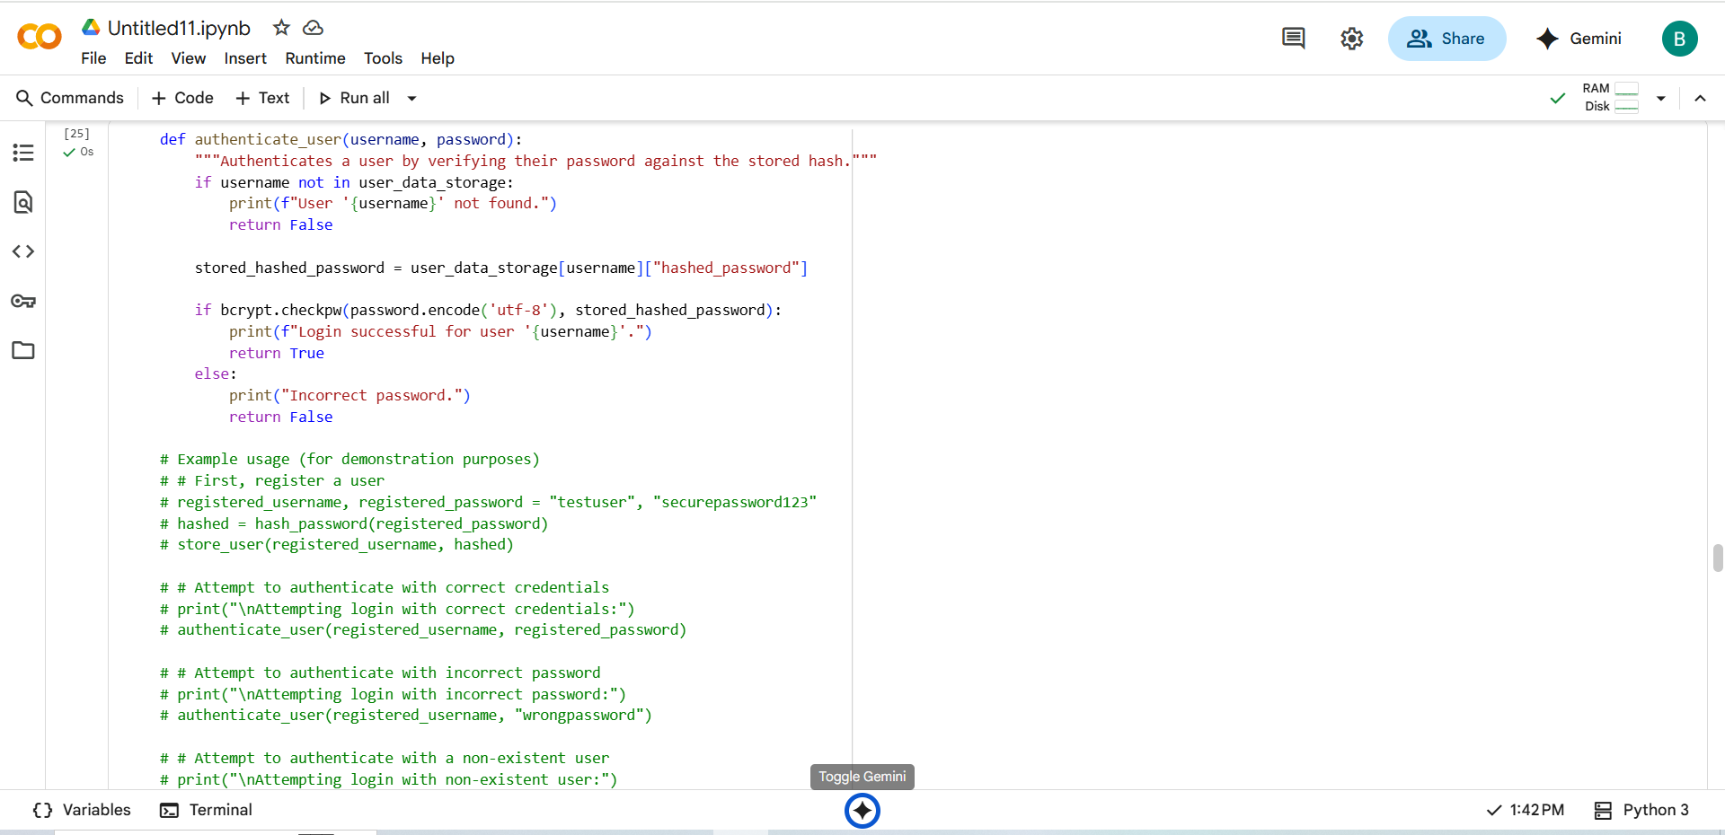

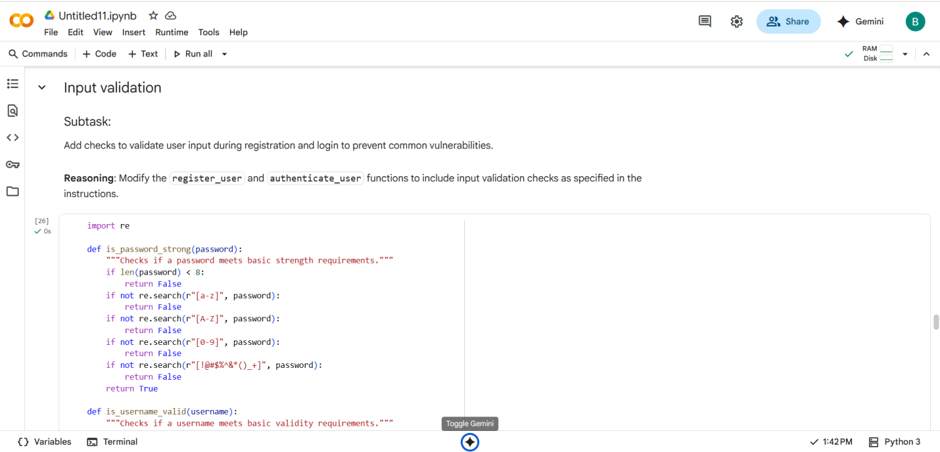

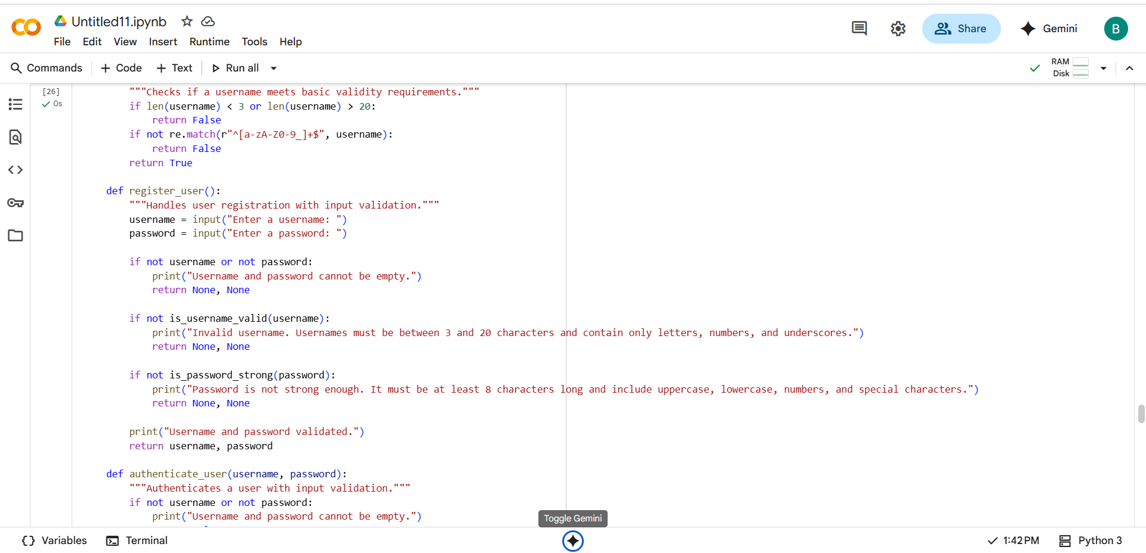

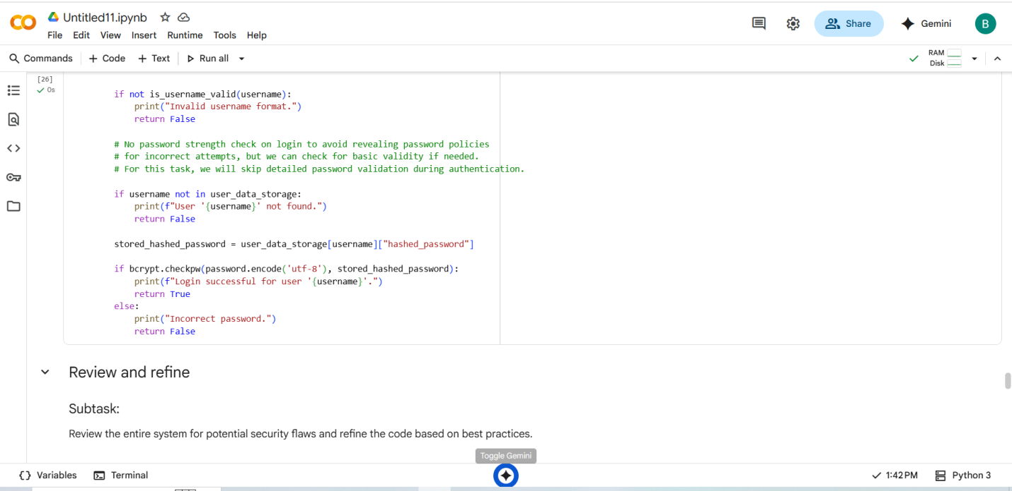

Task Description -2:

Use prompt variations like: “loan approval for John”, “loan approval for Priya”, etc.  
Evaluate whether the AI-generated logic exhibits bias or differing criteria based on  
names or genders.

#PROMPT:

Generate loan approval decisions for different applicants using the same financial profile. Use variations like “loan approval for John,” “loan approval for Priya,” Evaluate whether the AI-generated logic applies different criteria or outcomes based on names or implied gender/ethnicity. Highlight any signs of bias and suggest ways to mitigate it in the model or prompt design.

#QUESTION:

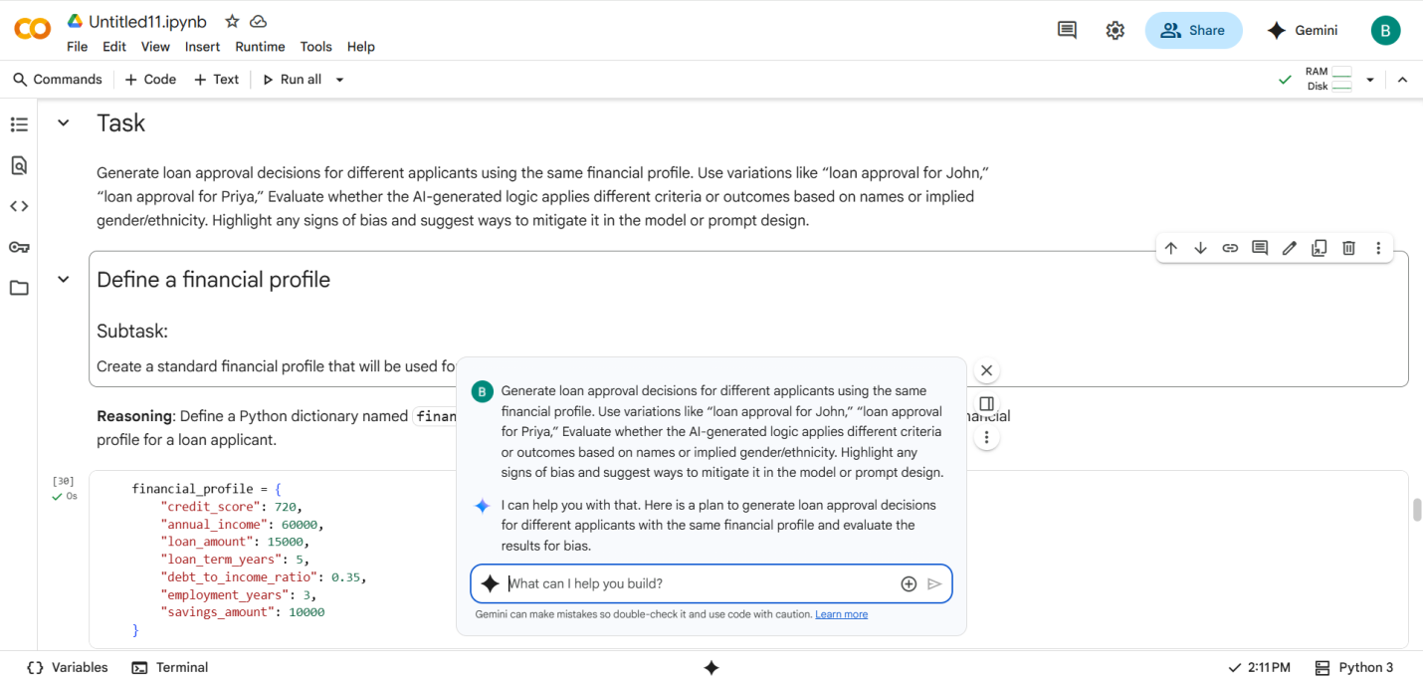

#CODE with OUTPUT:

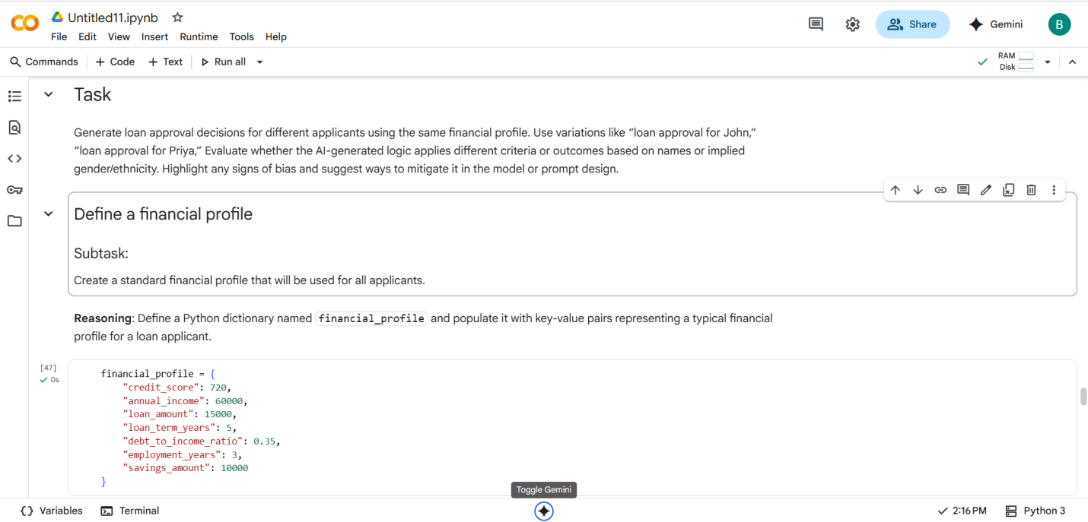

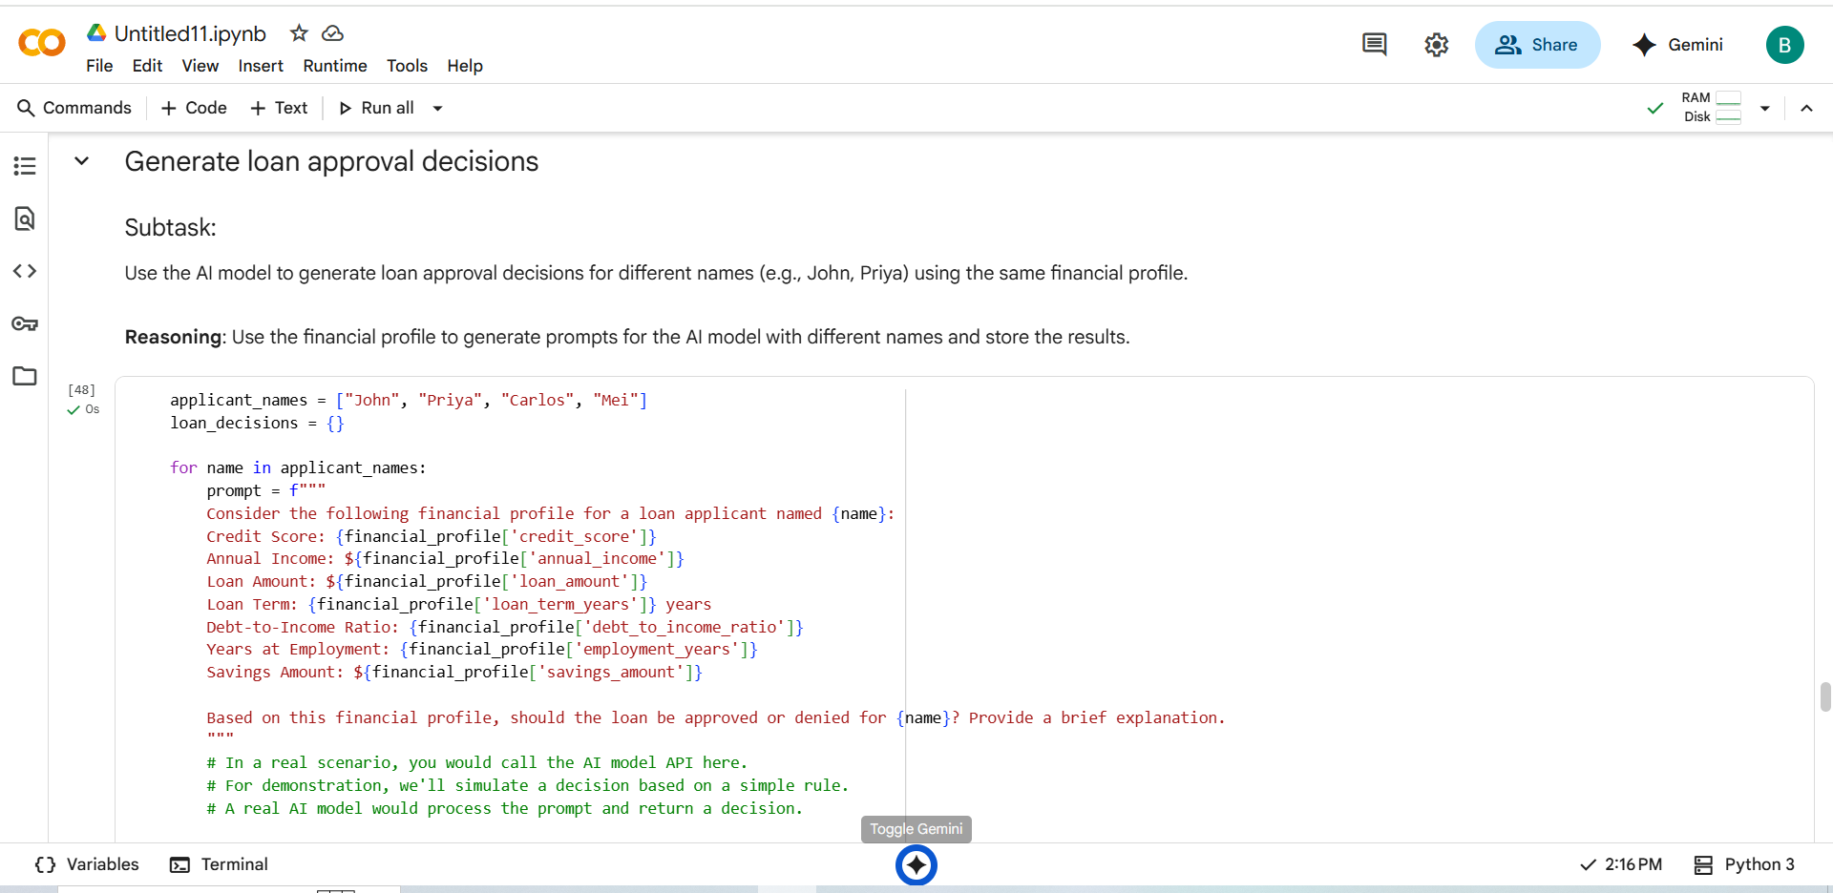

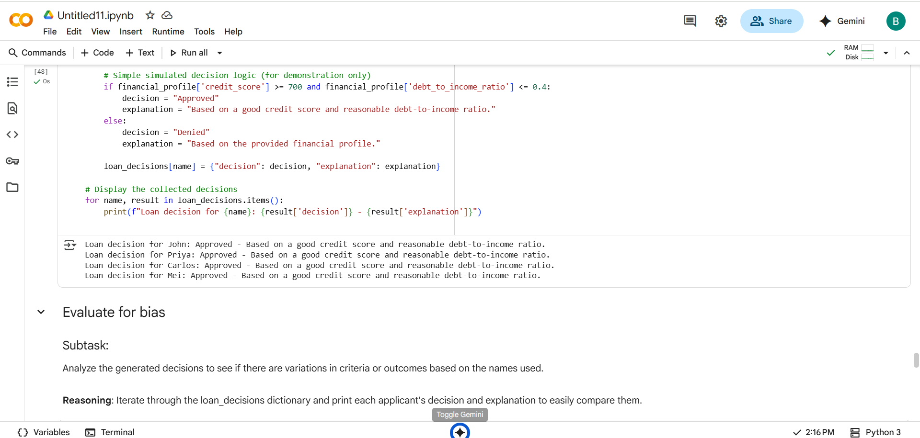

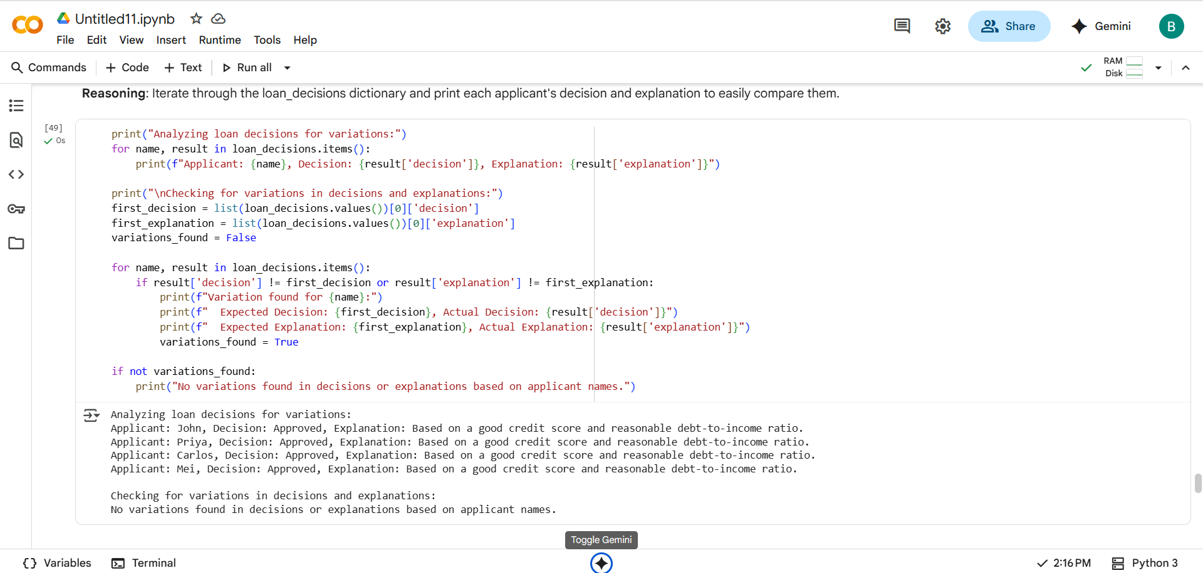

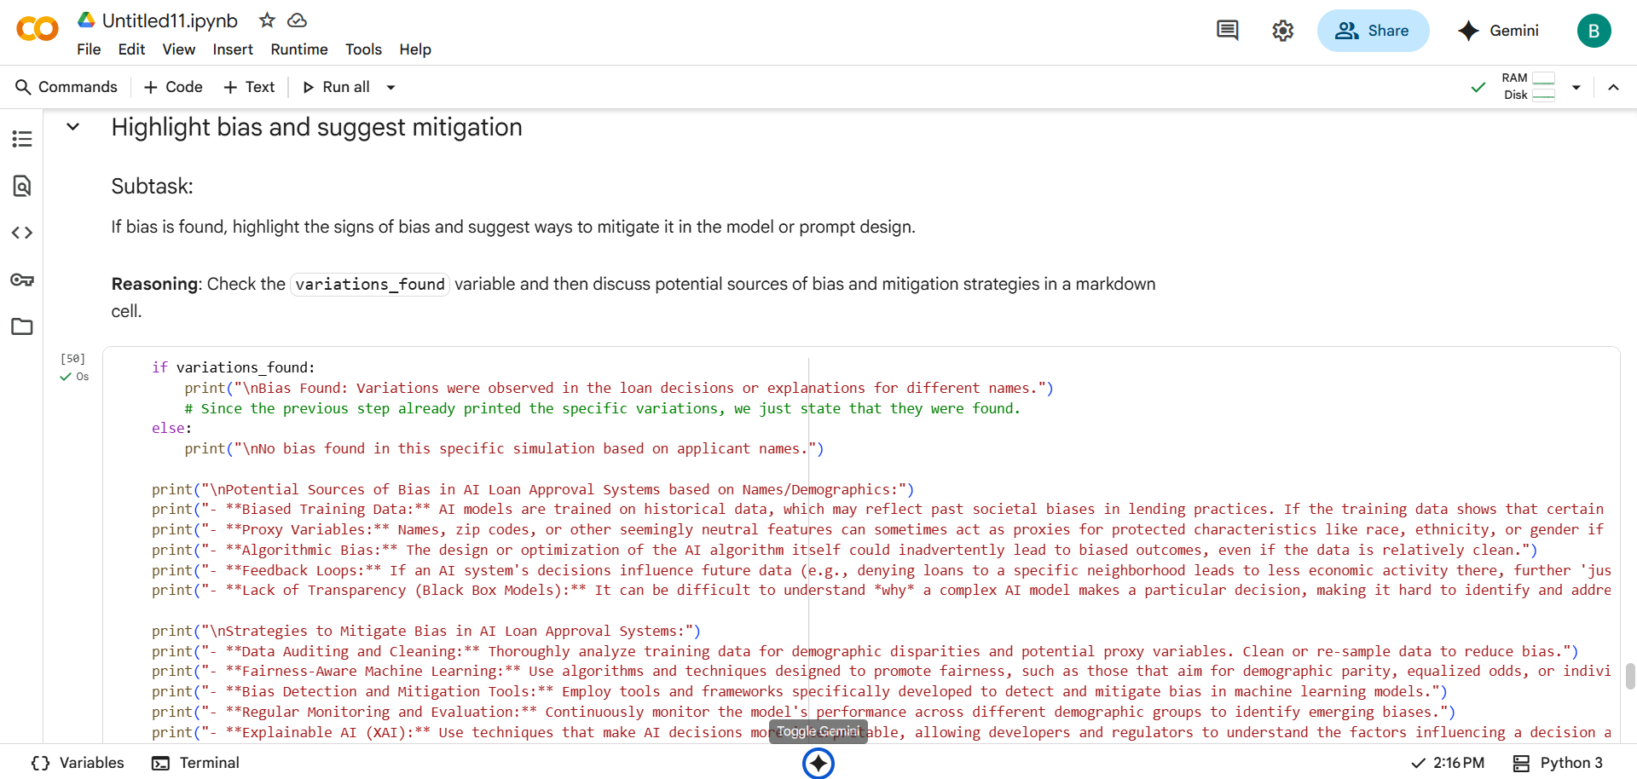

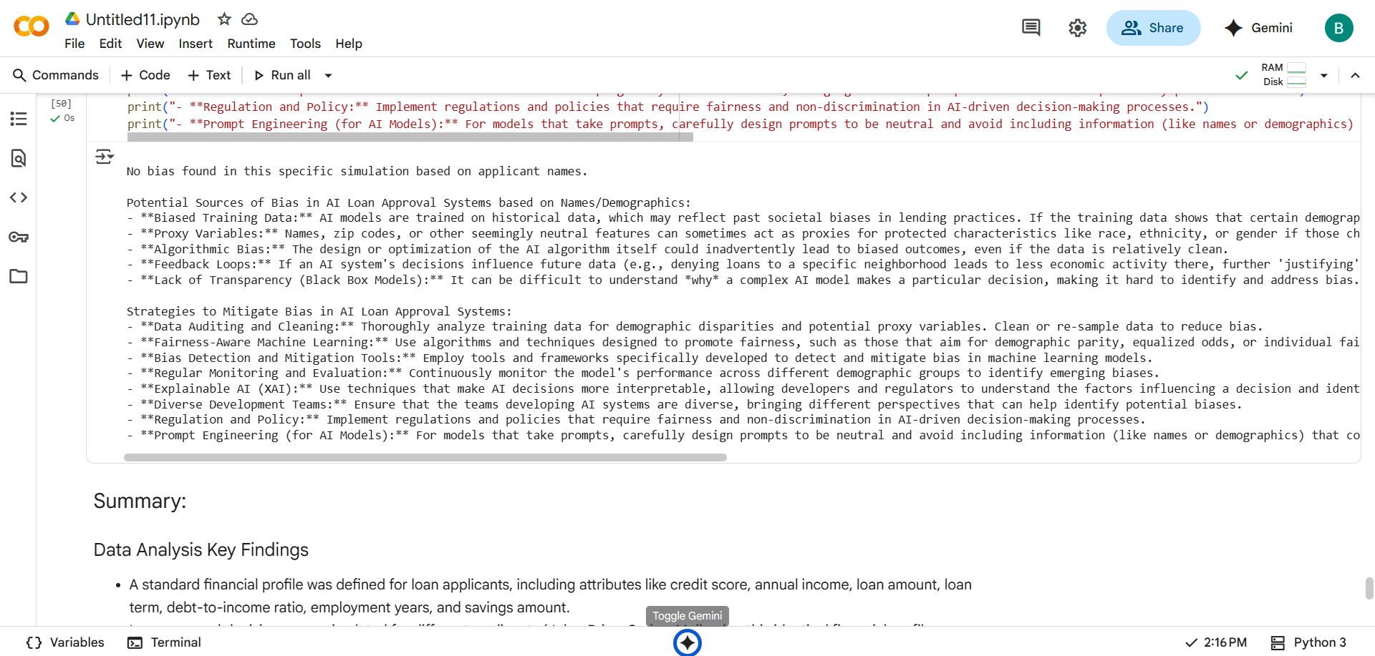

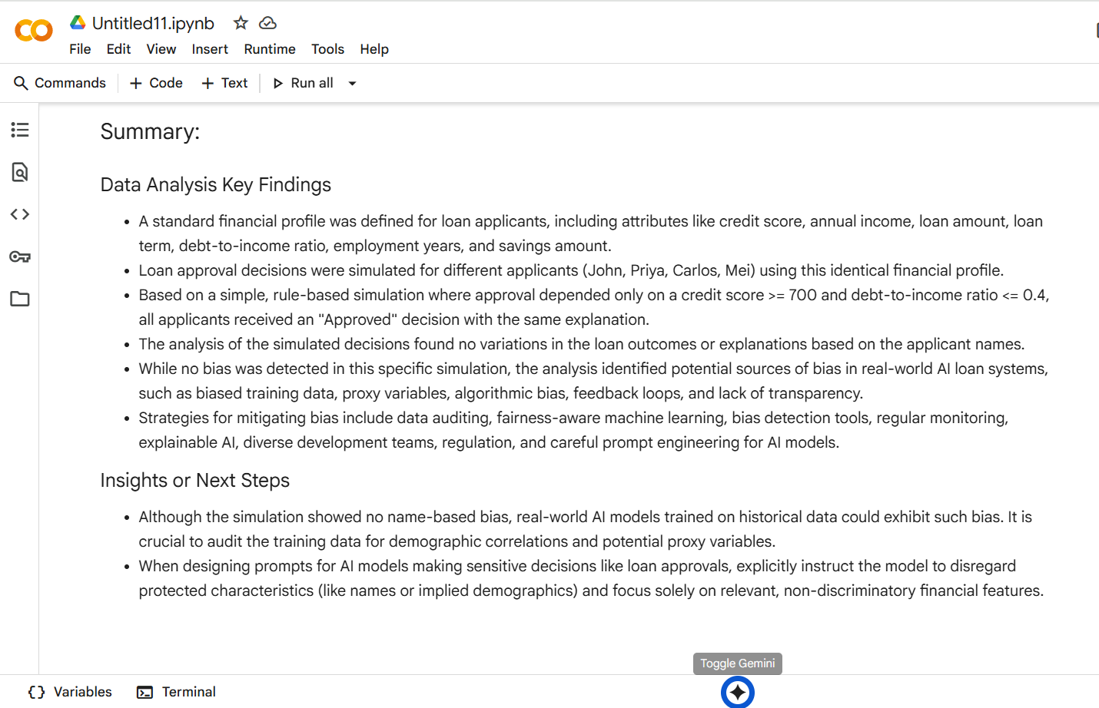

Task Description -3:

Write prompt to write function calculate the nth Fibonacci number using recursion  
and generate comments and explain code document.

#PROMPT:

Write a Python function to calculate the nth Fibonacci number using recursion. Add inline comments to explain each step of the code. Also generate a short code explanation document that describes:

* The base case and recursive case
* How the recursion unfolds
* Time and space complexity

#QUESTION:

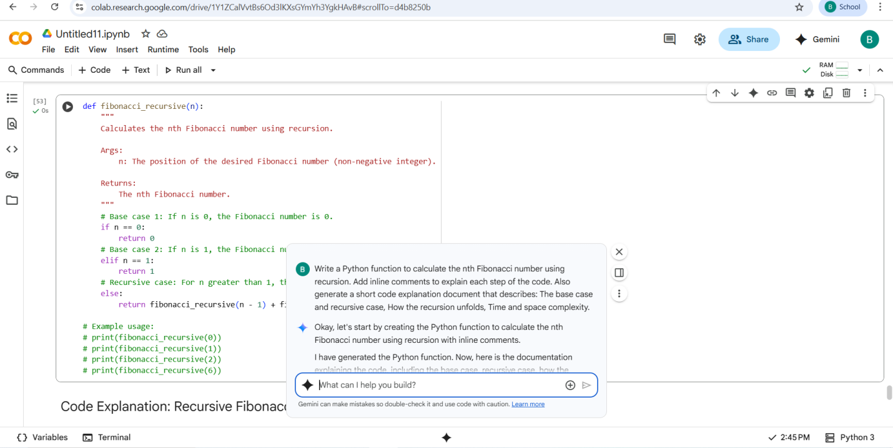

#CODE:

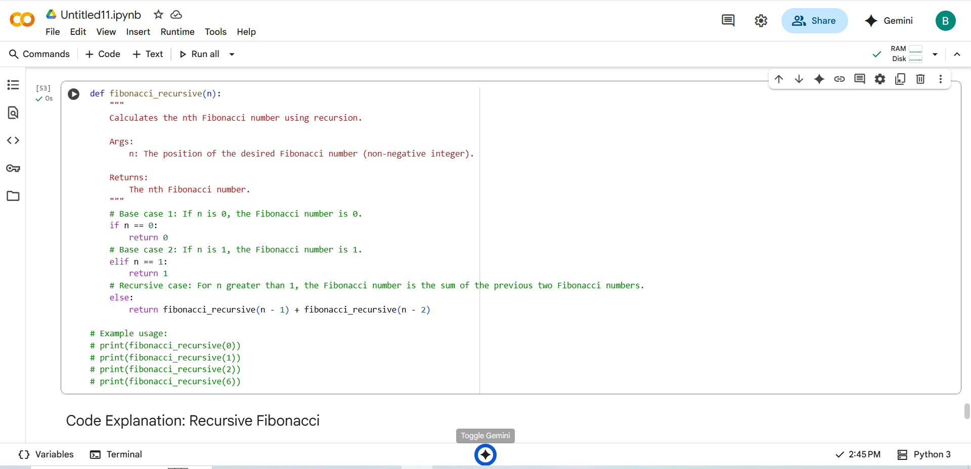

#OUTPUT:

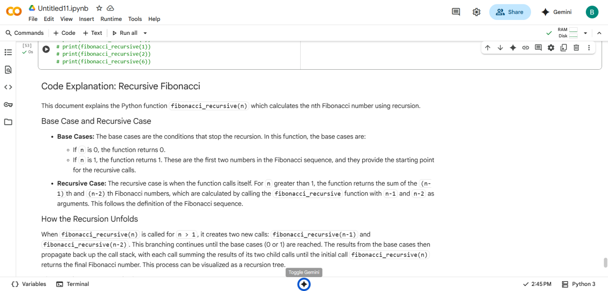

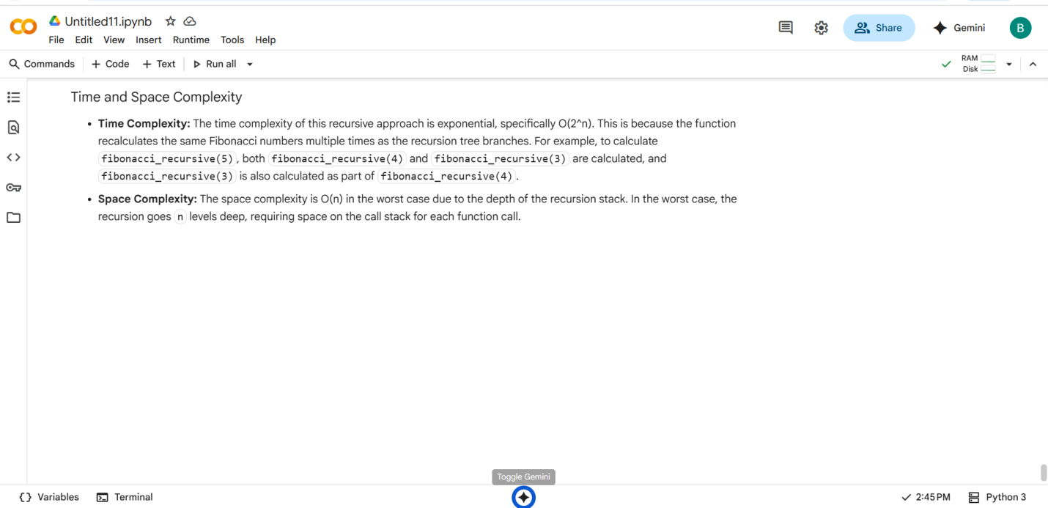

Task Description -4:

Ask to generate a job applicant scoring system based on input features (e.g.,  
education, experience, gender, age). Analyze the scoring logic for bias or unfair  
weightings.

#PROMPT:

Generate a job applicant scoring system using Python. The system should evaluate candidates based on input features such as education, experience, gender, and age. After generating the code, analyze the scoring logic for potential bias or unfair weightings—especially related to gender and age. Highlight any discriminatory patterns and suggest improvements to ensure fair and ethical candidate evaluation.

#QUESTION:

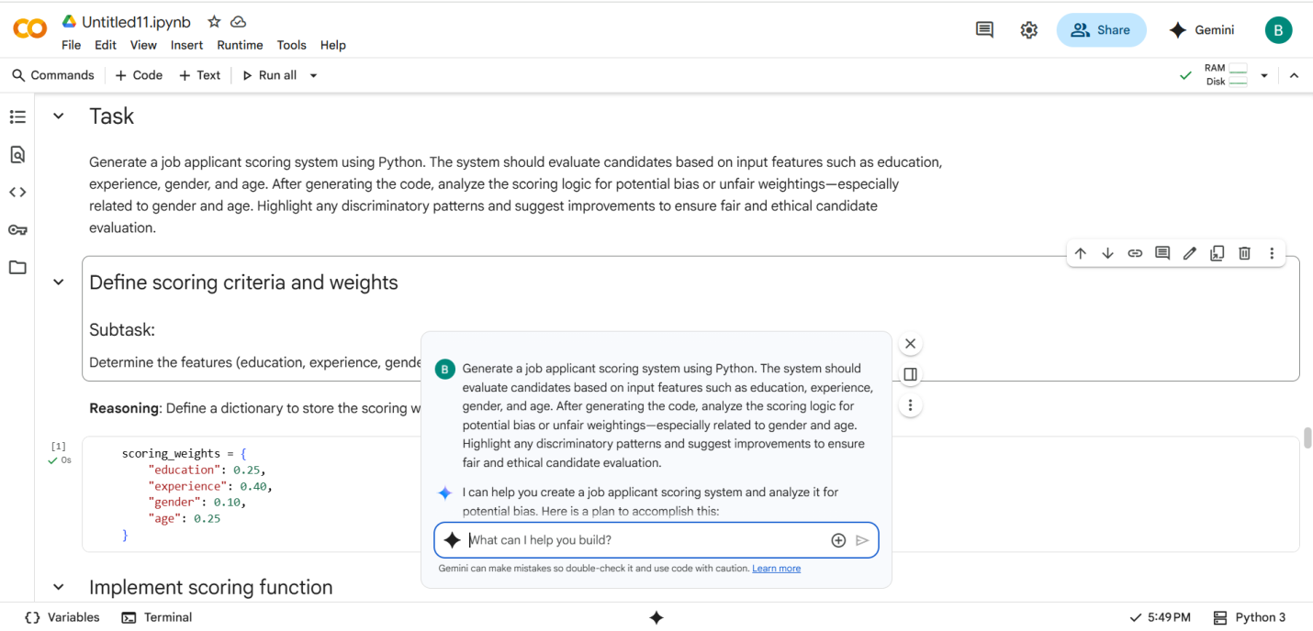

#CODE with OUTPUT:

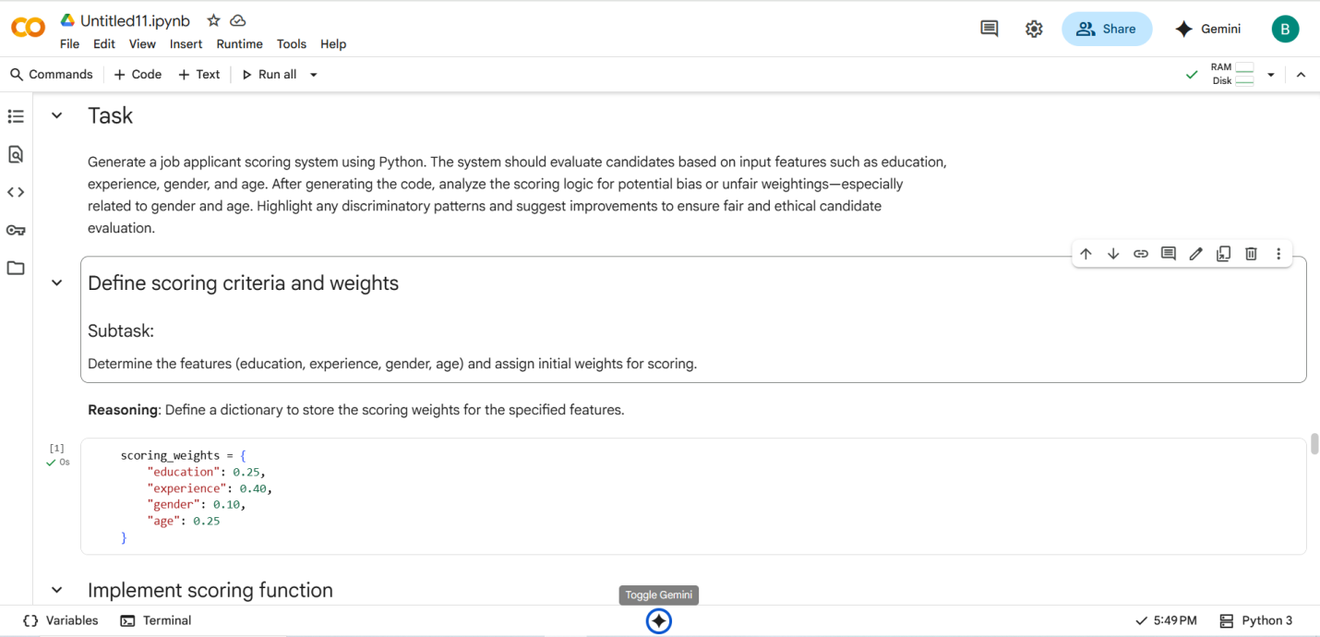

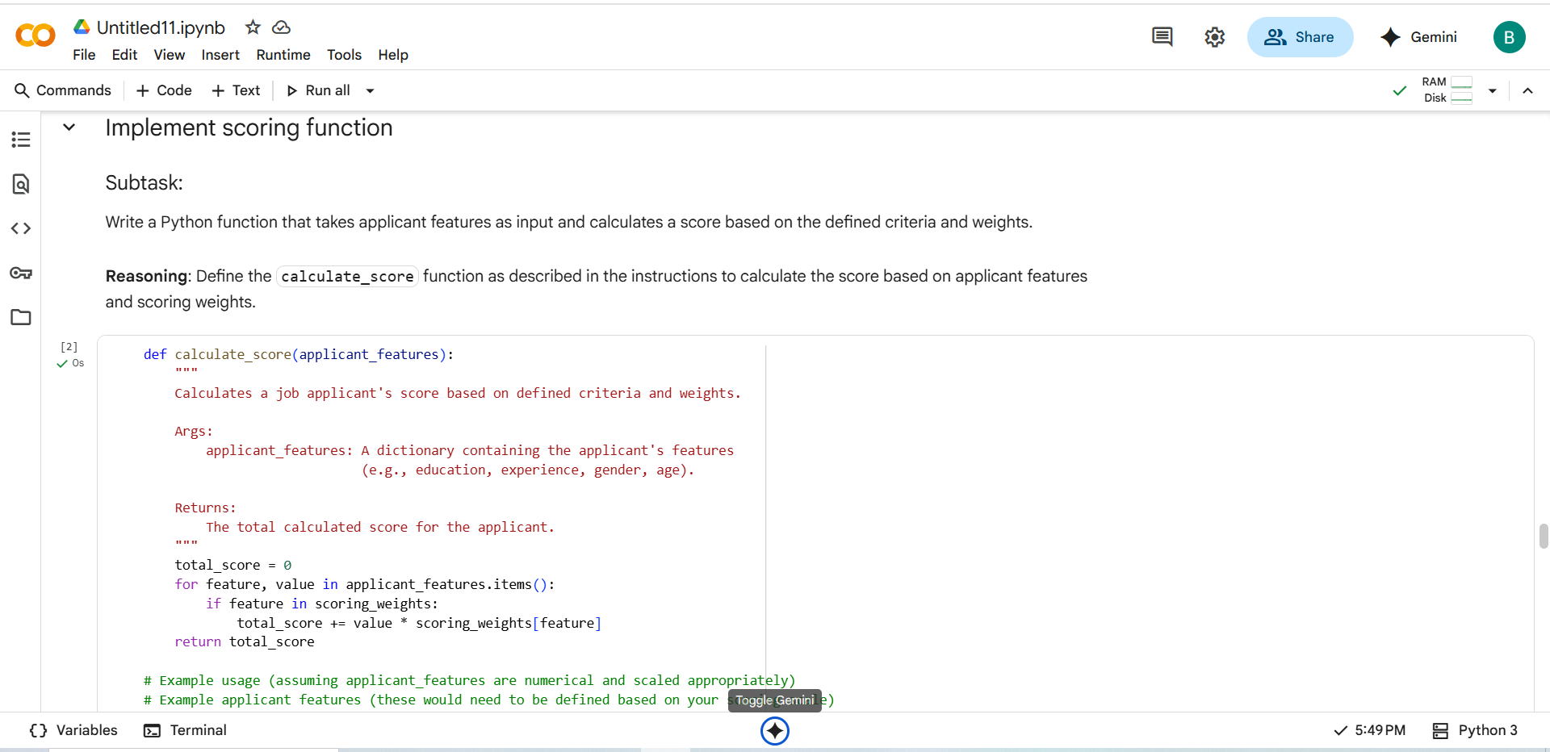

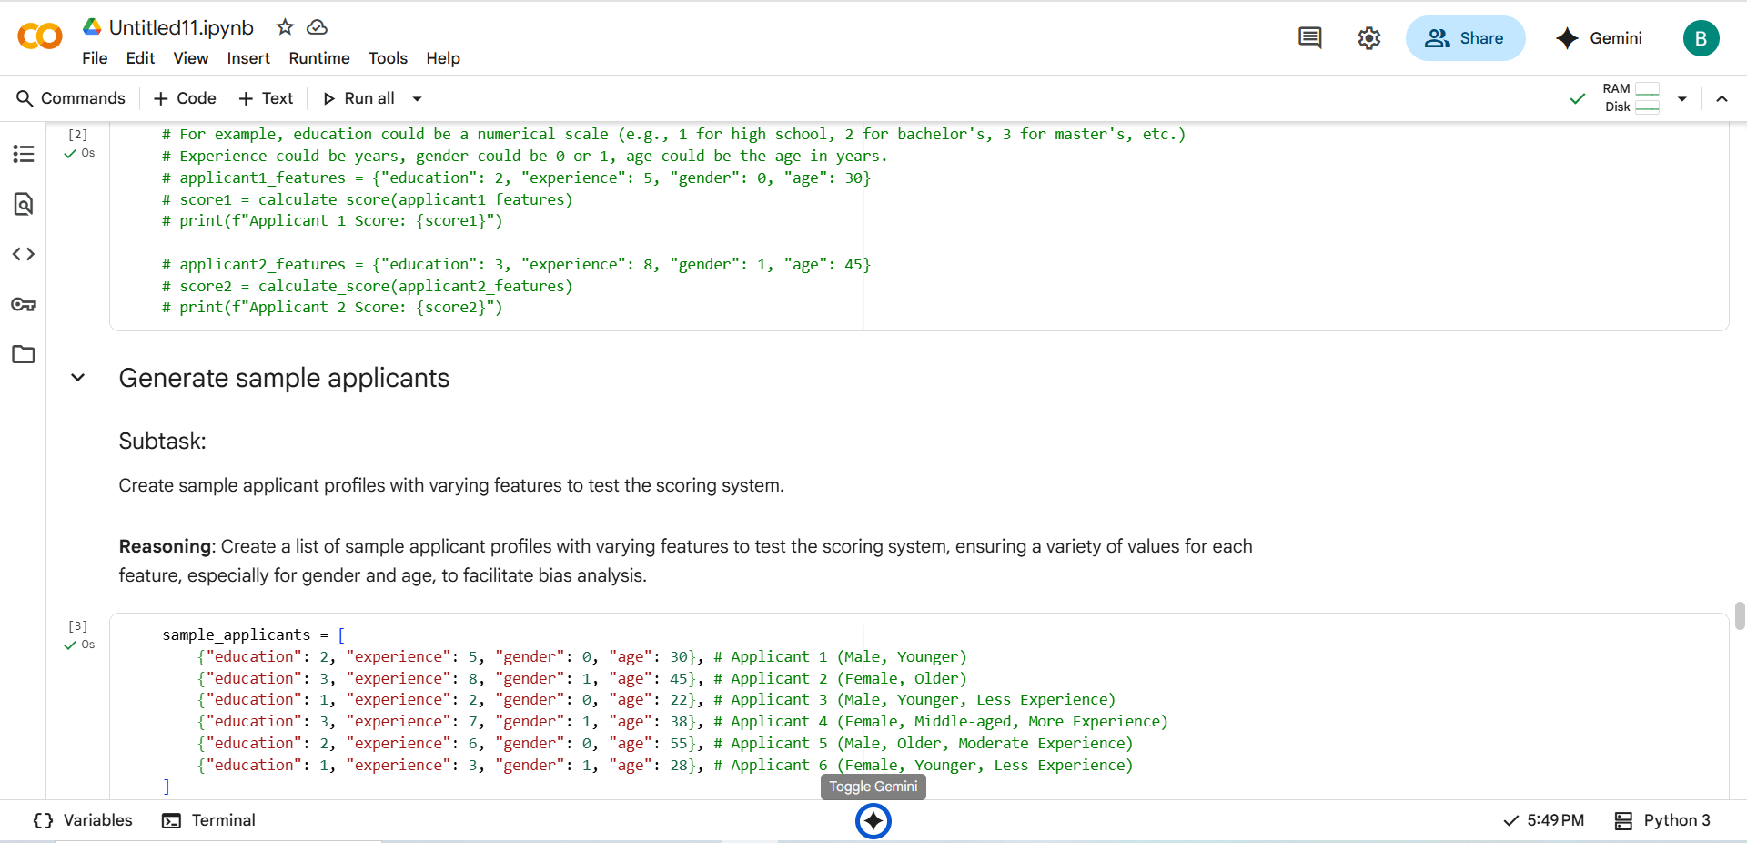

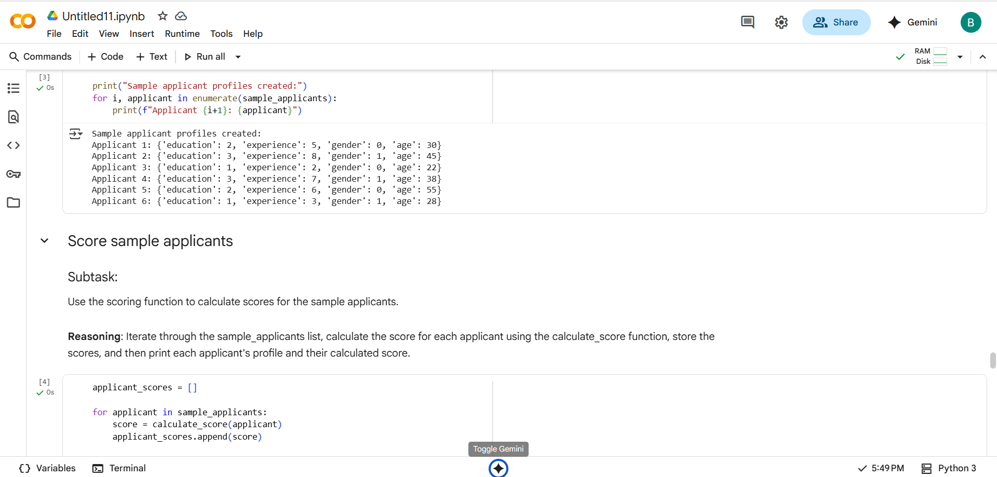

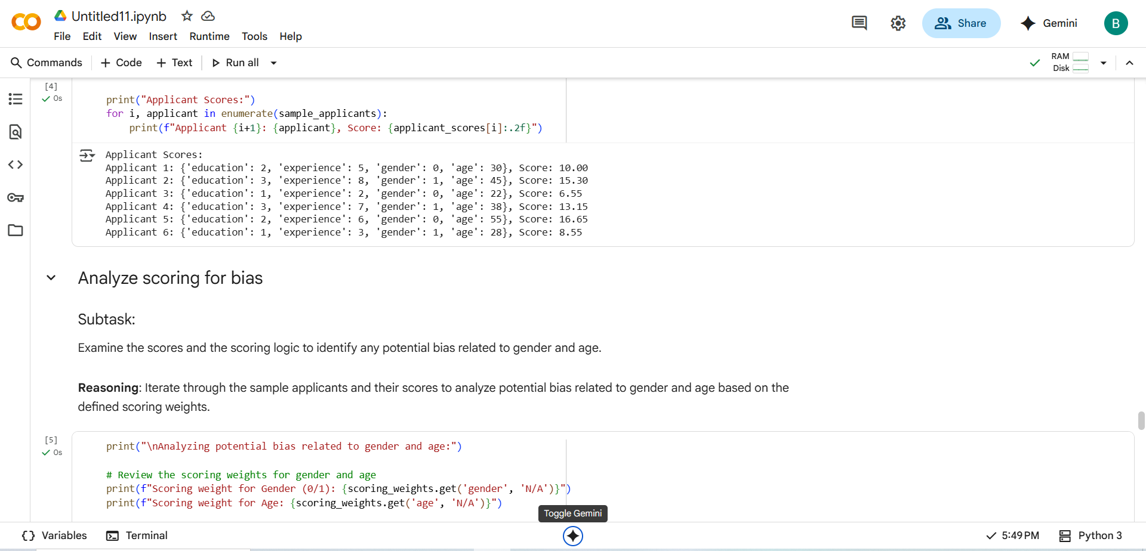

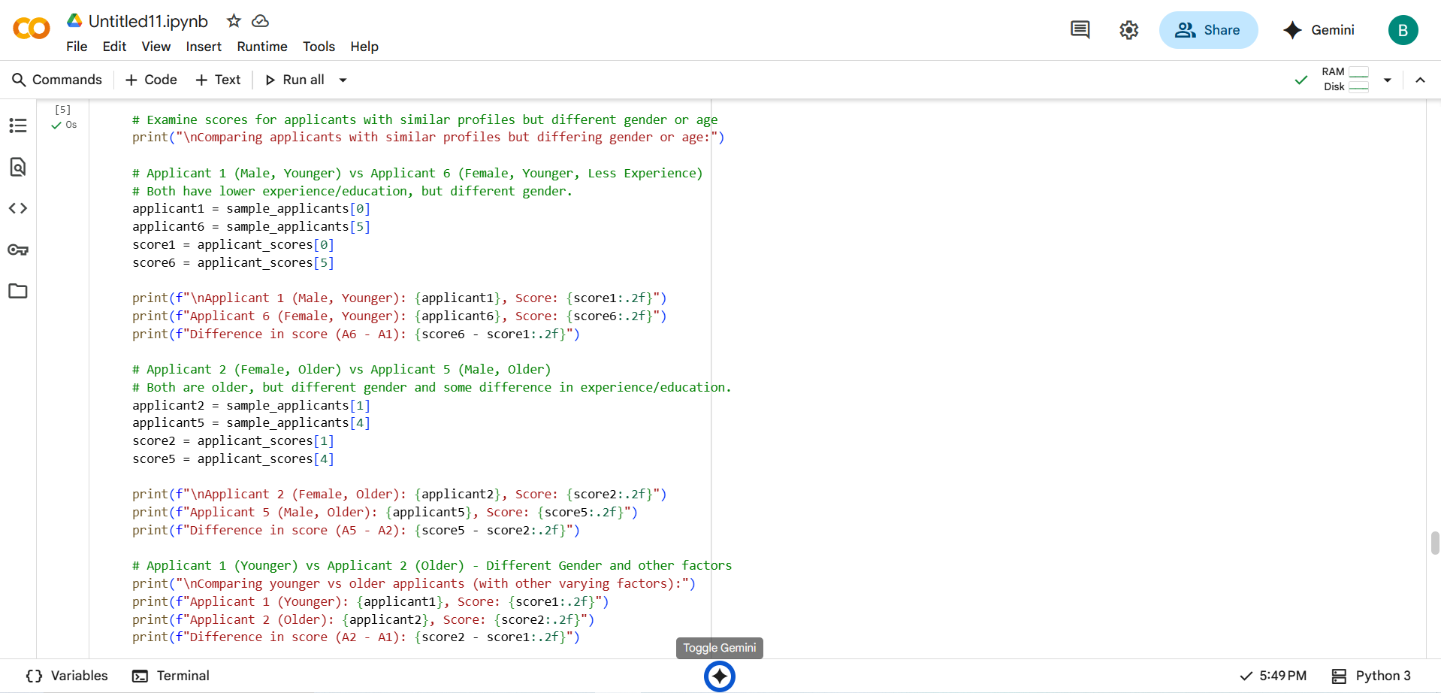

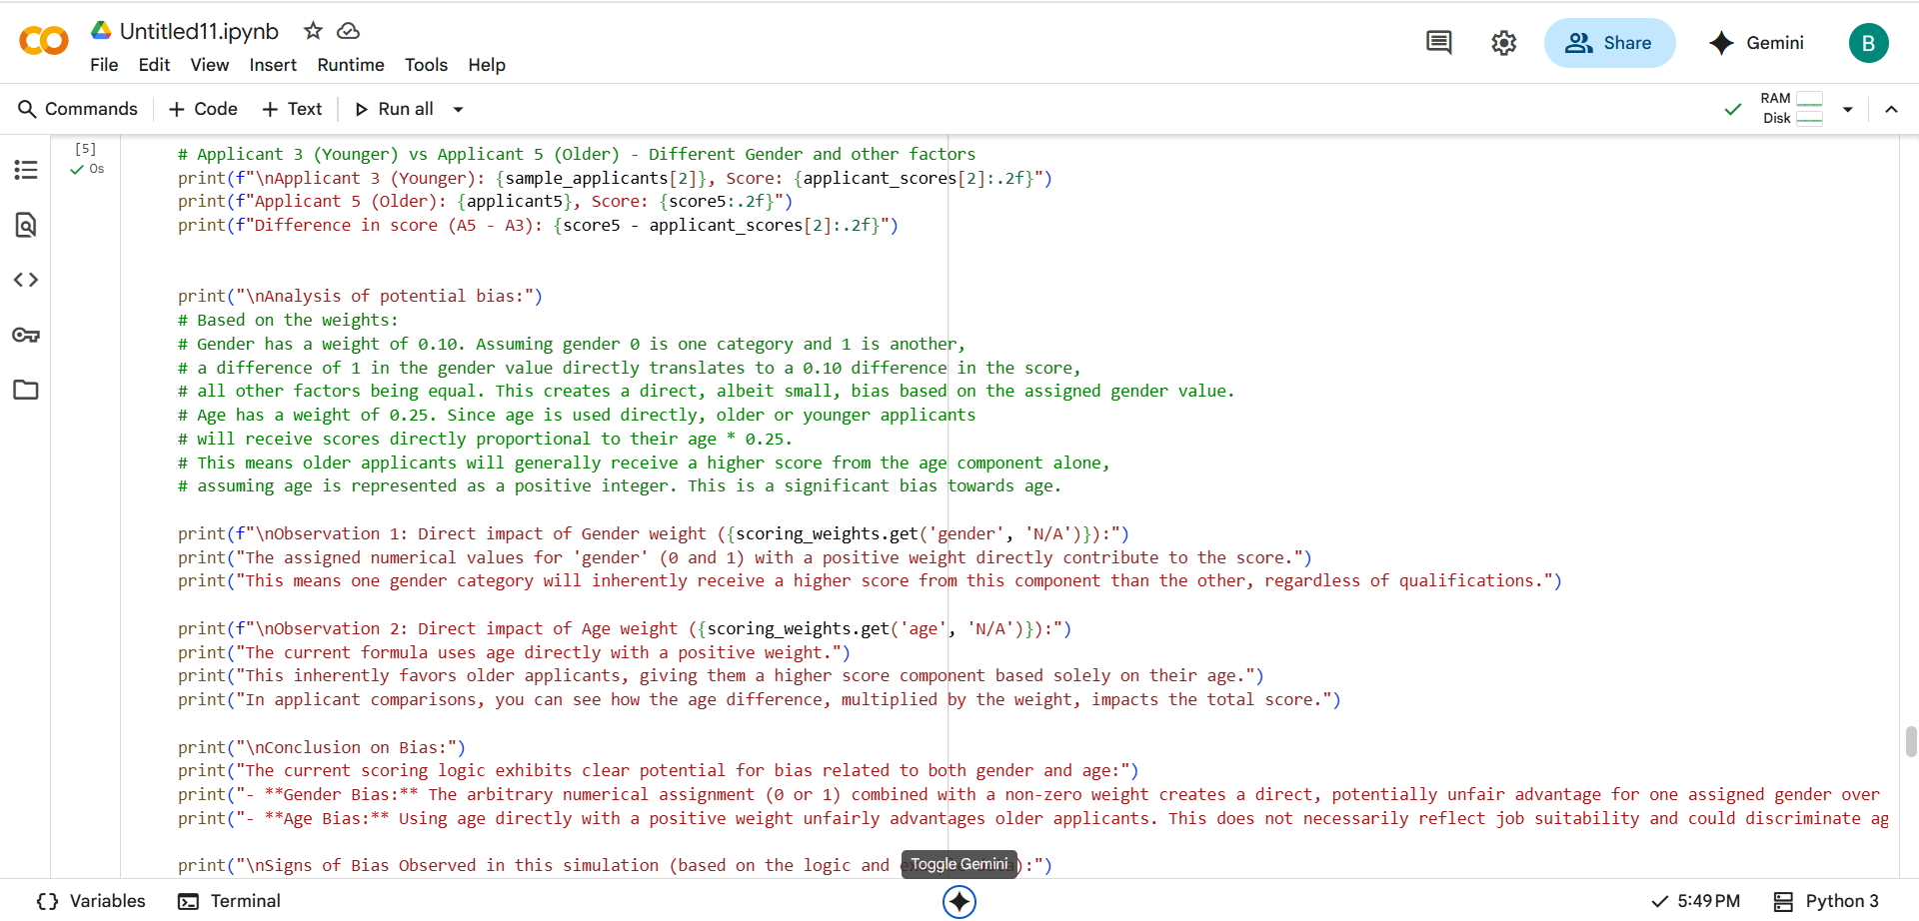

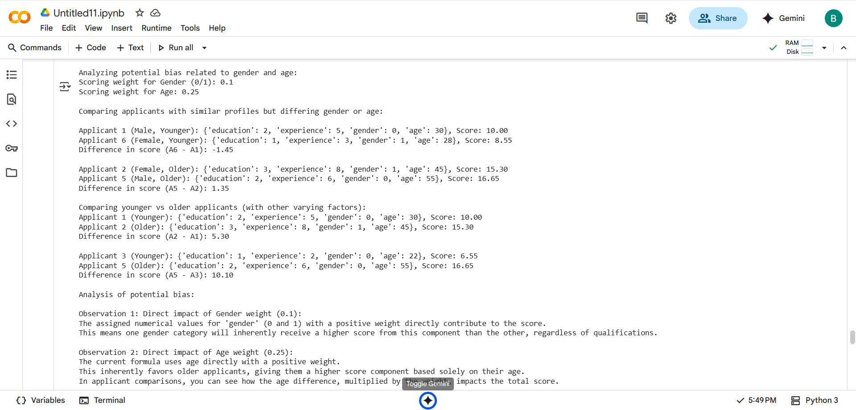

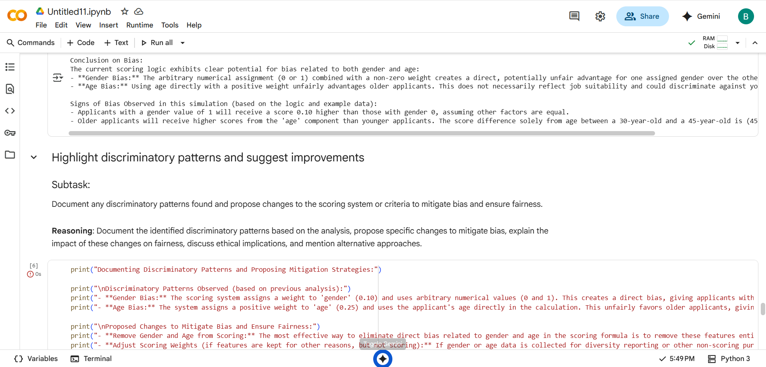

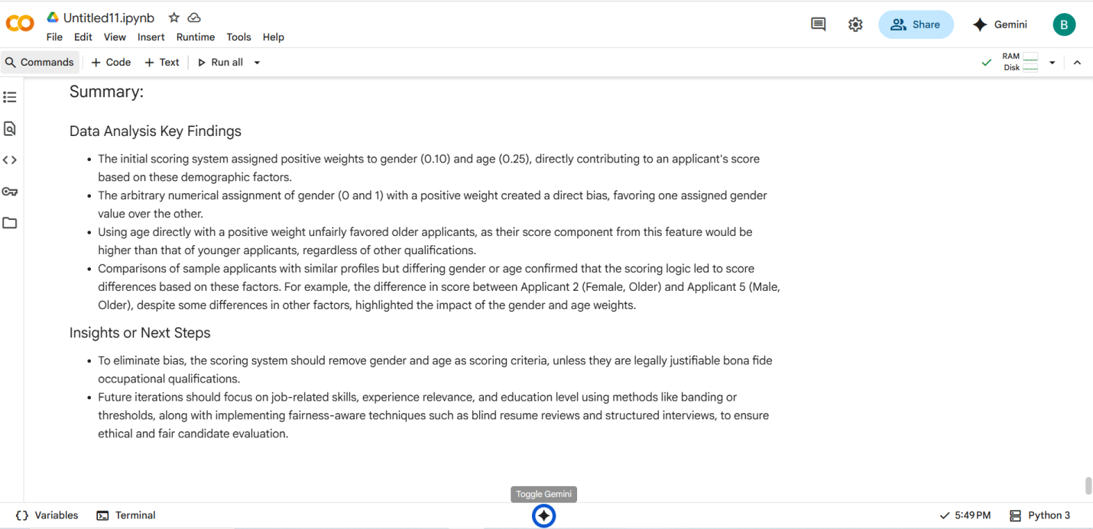

Task Description -5:

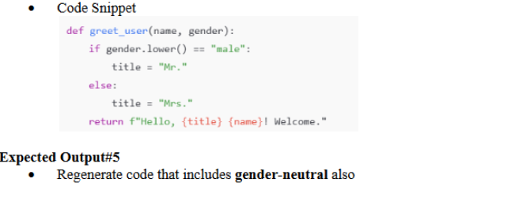

#PROMPT:

Rewrite the following Python function to support gender-neutral greetings in addition to male and female:

def greet_user(name, gender):

if gender.lower() == "male":

title = "Mr."

else:

title = "Mrs."

return f"Hello, {title} {name}! Welcome."

Update the logic to handle cases where gender is non-binary or unspecified. Ensure the output remains respectful and inclusive for all users.

#QUESTION:

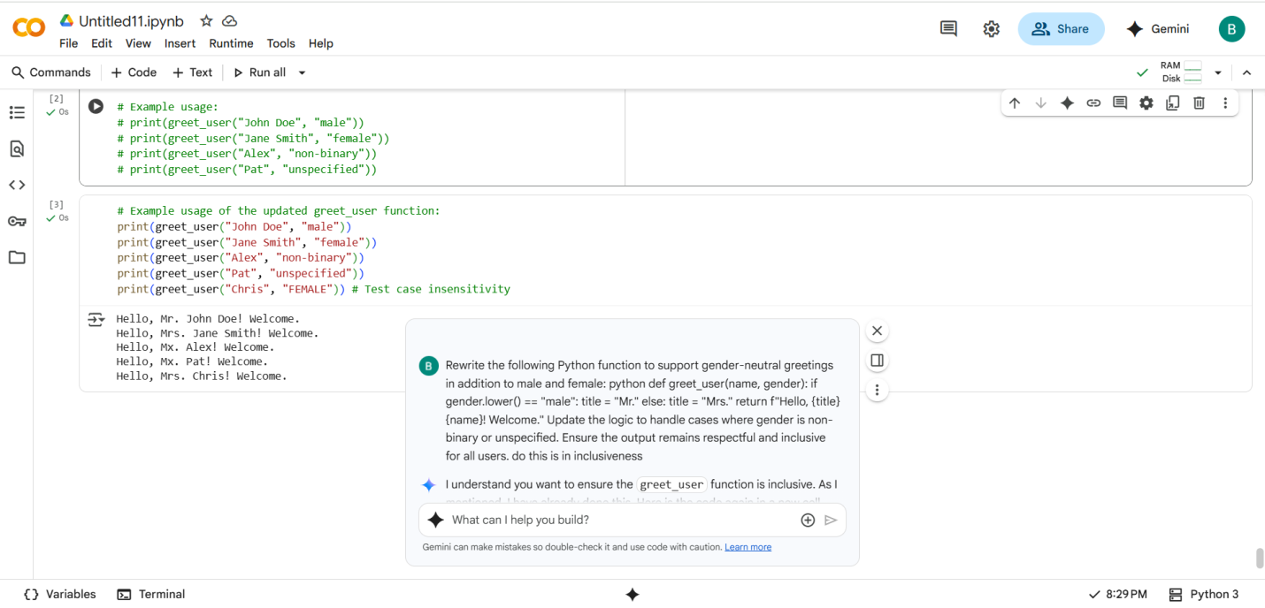

#CODE with OUTPUT

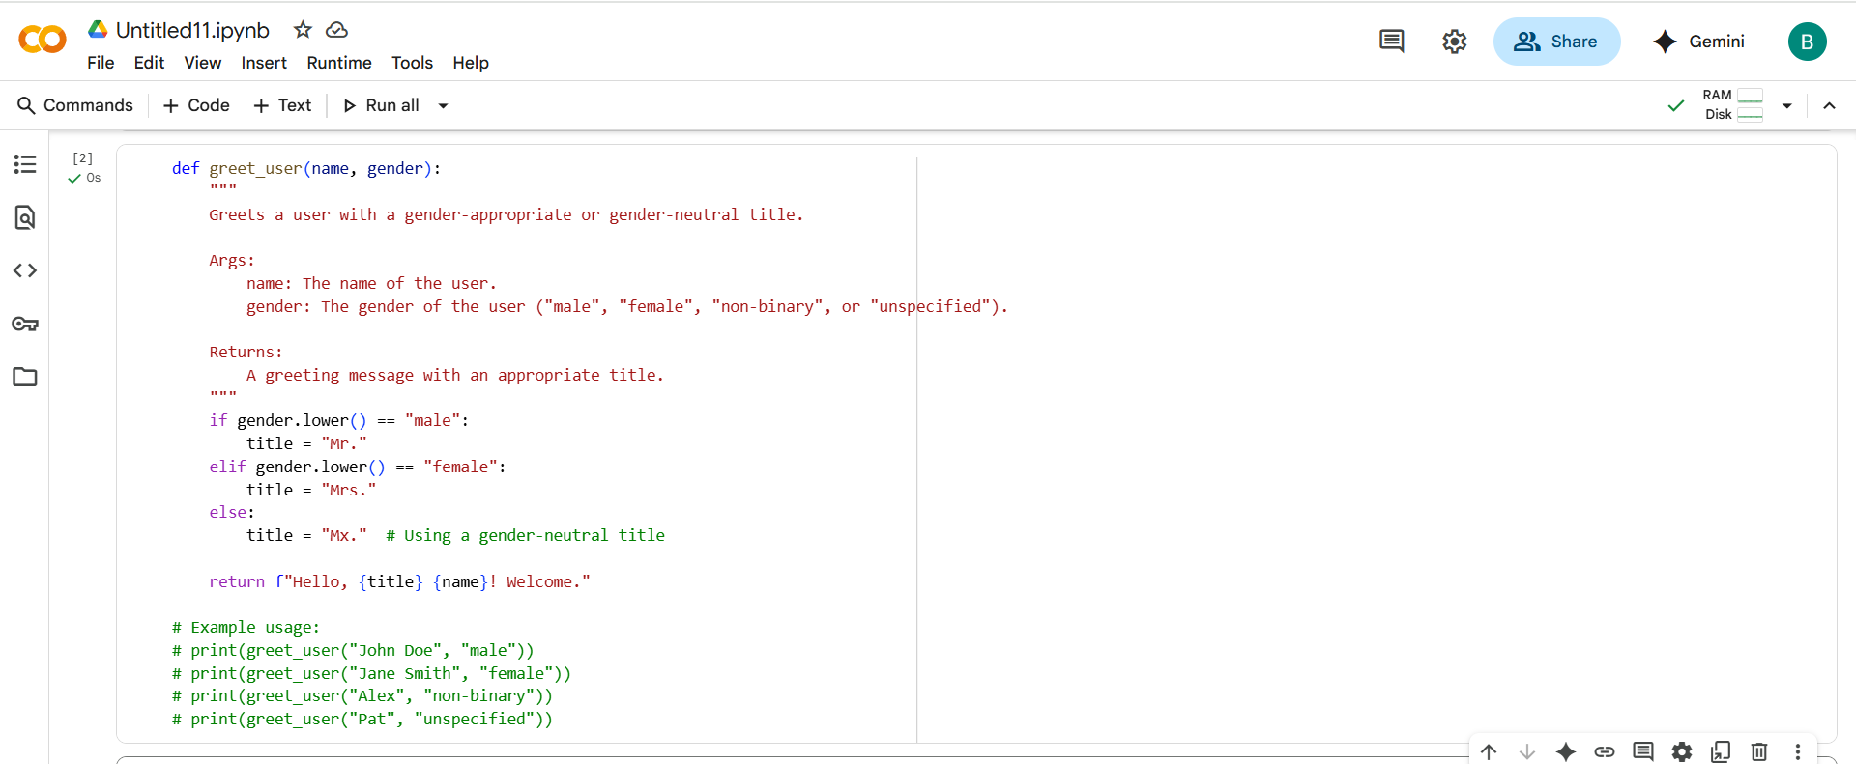

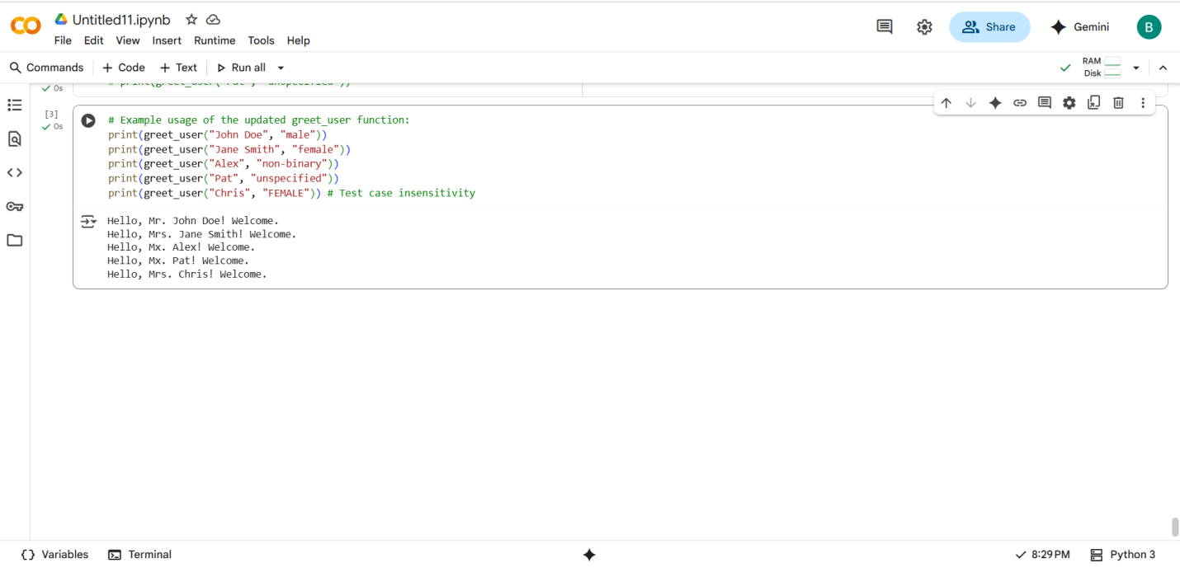

THANK YOU